Act1a. P-26
1. footbal
2. Hockey, rugby
3. Judo, karate
4. Badminton, table tennis (ping pong)
5. Rowing
6. Jogging (correr, no se llama footing)
7. Football, basketball,
8. Basketball, chess
9. Dressage, equestrian sports
10. chess

Act2.
1.Football. It is the most extended sport in the world.
2. Skydiving, bungee jump, motor racing.
3. Basketball. There are too many rules.
4. Football. You can be good at it but it is really hard to be the best nowadays.
5.
6. Tennis. I always have liked it since I was a child.

Act5.
1. spectator
2. fanatic / fan
3. coach
4. referee
5. amateur

Act7a p-27
1.Be on the ball
2. Move the goalpost
3. Take your eye off the ball
4. A level playing field
5.A whole new ball game
6.Score an own goal
7.Start the ball rolling
En el vocabulary de la unit3 estan explicades al español

Act 7b
a → 5
b → 1
c → 7
d → 2
e → 3
f → 6
g → 4

13/10/2020
Ex 2 p-28
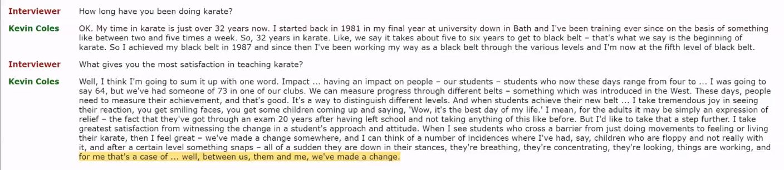
He does karate, he is a coach/teacher of karate.

Ex 3 p-28
Order of the listenning:
C. How long he has been doing karate.
B. How often he trains.
A. When he got his black belt.
G. Having an impact on people.
E. His oldest student.
F. Different belts.
D. How children react to getting a belt
H. How adults react to getting a belt.

Ex 4 p-28
1.
Hobby for most people. For other is part of their life.
2.
Children they are attracted because what they see on TV or videogames.
Instilling discipline or control.

Ex7 p-29
1.False. The DON’t come easily or overnight.
2. True. Line 22.
3. True. Over the last few years. Line 10
4. Not given.
5. True. First lesson free. Line 9
6.Not Given
7. Not Given
8. True. Lines 12 to 14

Ex8. NOT Correct
1. Children.
2. Violence.
3. Aggression
4. Courtesy

Ex10a p -29
Agile: agility. (ágil.)
Calm: Calm (Calmado)
Coordinated: Coordination (Coordinado)
Courteous: Courtesy (Cortesia)
Flexible: Flexibility (Flexibilidad)
Tolerant: Tolerance (Tolerancia)

GRAMMAR: Quantifiers P-29

Ex 11ap-29
Quantifier del texto p-28 | Traduccion act 11a
Several (Line 3)
Both (Line 6)
All (Line 5)
Few (Line 10)
Each of us (Line 11)
Some (Line 11)
A lot of (Line 14)
Far too many (Line 16)
A lot of (Line 17)
All times (Line 19)
Entire (Line 22)
Both (Line22)
Regular (Line 25)
Many (Line 29)
Some (Line 30)
A few of (Line 31)

Mirar la pagina 130 que possa amb cada tipus de cuantificador pot anar cada expressio. Per a contables, incontable o els dos.

Ex 1 P-131
1. a few. Tengo asi que puedo compartirlos.
2.any students. No es la of students porque hay que poner algo despues del students (p-130)
3.hardly any
4.none of “none of” porque despues del of hay un our. (p-130)
5.Several of “several of” por lo mismo que antes. Hay un my despues del of.
6. a little A little porque homework es incomtable
7. little No es contable furniture.
8. Few “No hay otro banco que…” Fes other banks...
9. much much porque rubbish/litter es incontable.

Ex 12 p-29
1. Some. Possitive meaning.
2.Not many. Negative thing.
3. Not much. Negative thing.
4. Some. Possitive meaning.

Ex 13 p-29
1.Several of my friends….
2.Far to many children lack...
3.Could you give me a little help?
4. Some of the parents… // A few of the parents...
5.Hardly any of the spectators left before the end of the game.
6. It’s great that we managed to get a few tickets.
7. This spot is so new that we have a little information about it. ← Sin la “a” en negrita. Esta tachada.

